QUADRATIC FUNCTIONS
- A function whose highest power is two (2).
- It is written in the form : $y=ax^{2}$

- The effect of the $a$ in $y=ax^{2}$

Complete the table below:

$$x$$ | -3 | -2 | -1 | 0 | 1 | 2 | 3
$$y=x^{2}$$ | 9 | 4 | 1 | 0 | 1 | 4 | 9
$$y=½x^{2}$$ | 4,5 | 2 | 0,5 | 0 | 0,5 | 2 | 4,5
$$y=2x^{2}$$ | 18 | 4 | 2 | 0 | 2 | 4 | 18
$$y=-x^{2}$$
$$y=-½x^{2}$$
$$y=-2x^{2}$$

EXERCISE

- Copy and complete the table above.
- Using different colours plot the six(6) functions on the Cartesian plane like the one below:
- What do you notice?
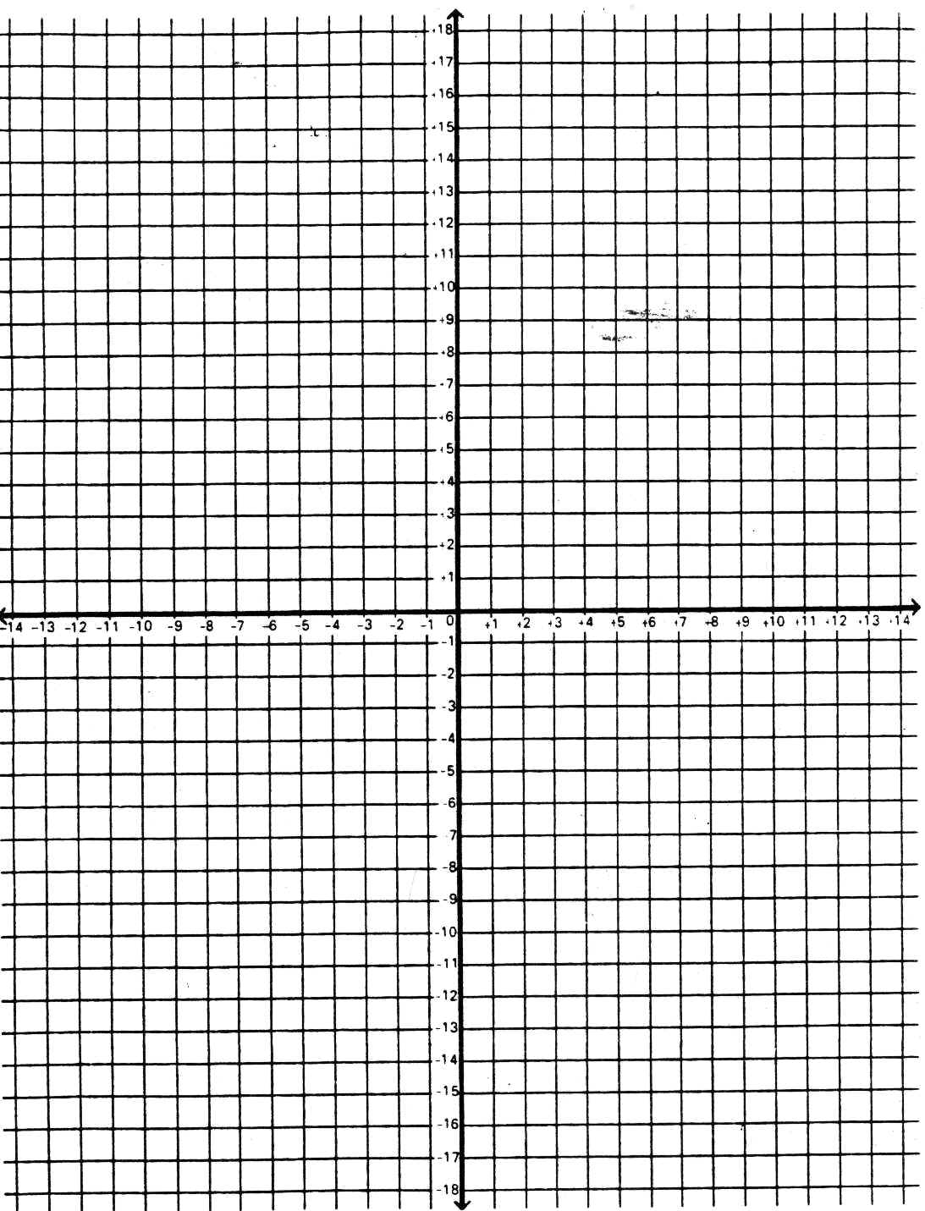

The effect of the $q$ in $y=ax^{2}+q$

Complete the table below:

$$x$$ | -3 | -2 | -1 | 0 | 1 | 2 | 3
$y=x^{2}+$2 | 11 | 6 | 3 | 2 | 3 | 6 | 11
$$y=x^{2}-2$$ | 7 | 2 | -1 | -2 | -1 | 2 | 7
$$y=x^{2}$$ | 9 | 4 | 1 | 0 | 1 | 4 | 9
$$y=-x^{2}+2$$
$$y=-x^{2}-2$$

EXERCISE

- Copy and complete the table above.
- Using different colours plot the six(6) functions on the Cartesian plane like the one below:
- What do you notice?

